**EV Market Segmentation Analysis**

Following analysis is based on **Geographical** segmentation variable representations of EV market in India across states and cities.

**Data**

Data used in this study have been taken from government websites and from Kaggle.

1. <https://dash.heavyindustries.gov.in/dhiev>
2. <https://data.gov.in/search?title=ELECTRIC%20VEHICLES>

Data on total no. electric vehicles, no. charging stations, vehicle population have been used to generate visualizations giving an insight how Indian EV market is distributed across India.

**EDA**

To visualize the penetration of Electric vehicle in Indian Automobile sector comparison with other fuel type vehicle we first need to project total vehicle population.

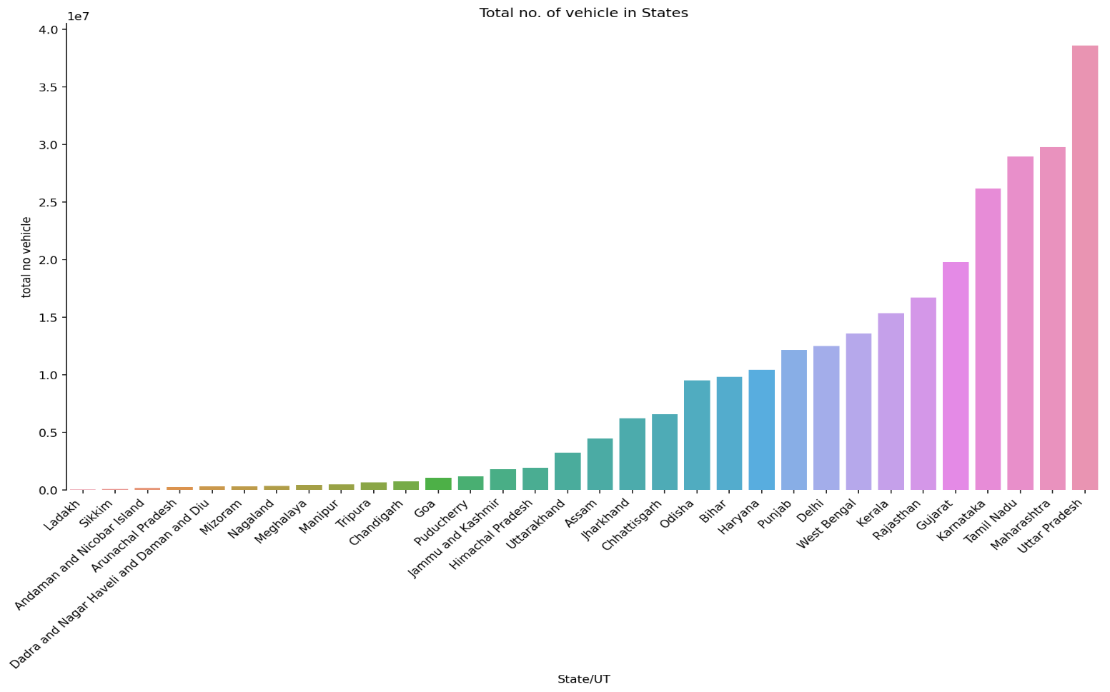

Here only we can easily infer from the above that the states like Uttar Pradesh, Maharashtra, Tamil Nadu, Karnataka and Gujrat are among the top 5 vehicle population that may be reason of human population, wealth ratio or spending behaviour that can describe this but that is a different aspect of segmentation.

Projection of electric vehicle in India

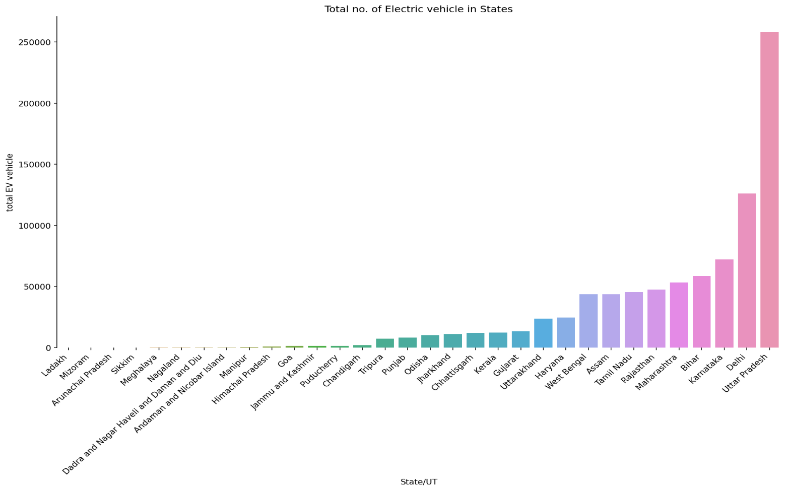

States Uttar Pradesh, Delhi, Karnataka, Bihar and Maharashtra are having top numbers of electric population.

Comparing the ratio of total vehicle with that of EV’s in that state we can derive that people of Tripura, Delhi, Assam, Uttara Khand and Uttar Pradesh are having an edge in adopting Electric Vehicle as their choice. May be, it is the impact of literacy, awareness about pollution or the government schemes that leads to it. That’s rest to further insights.

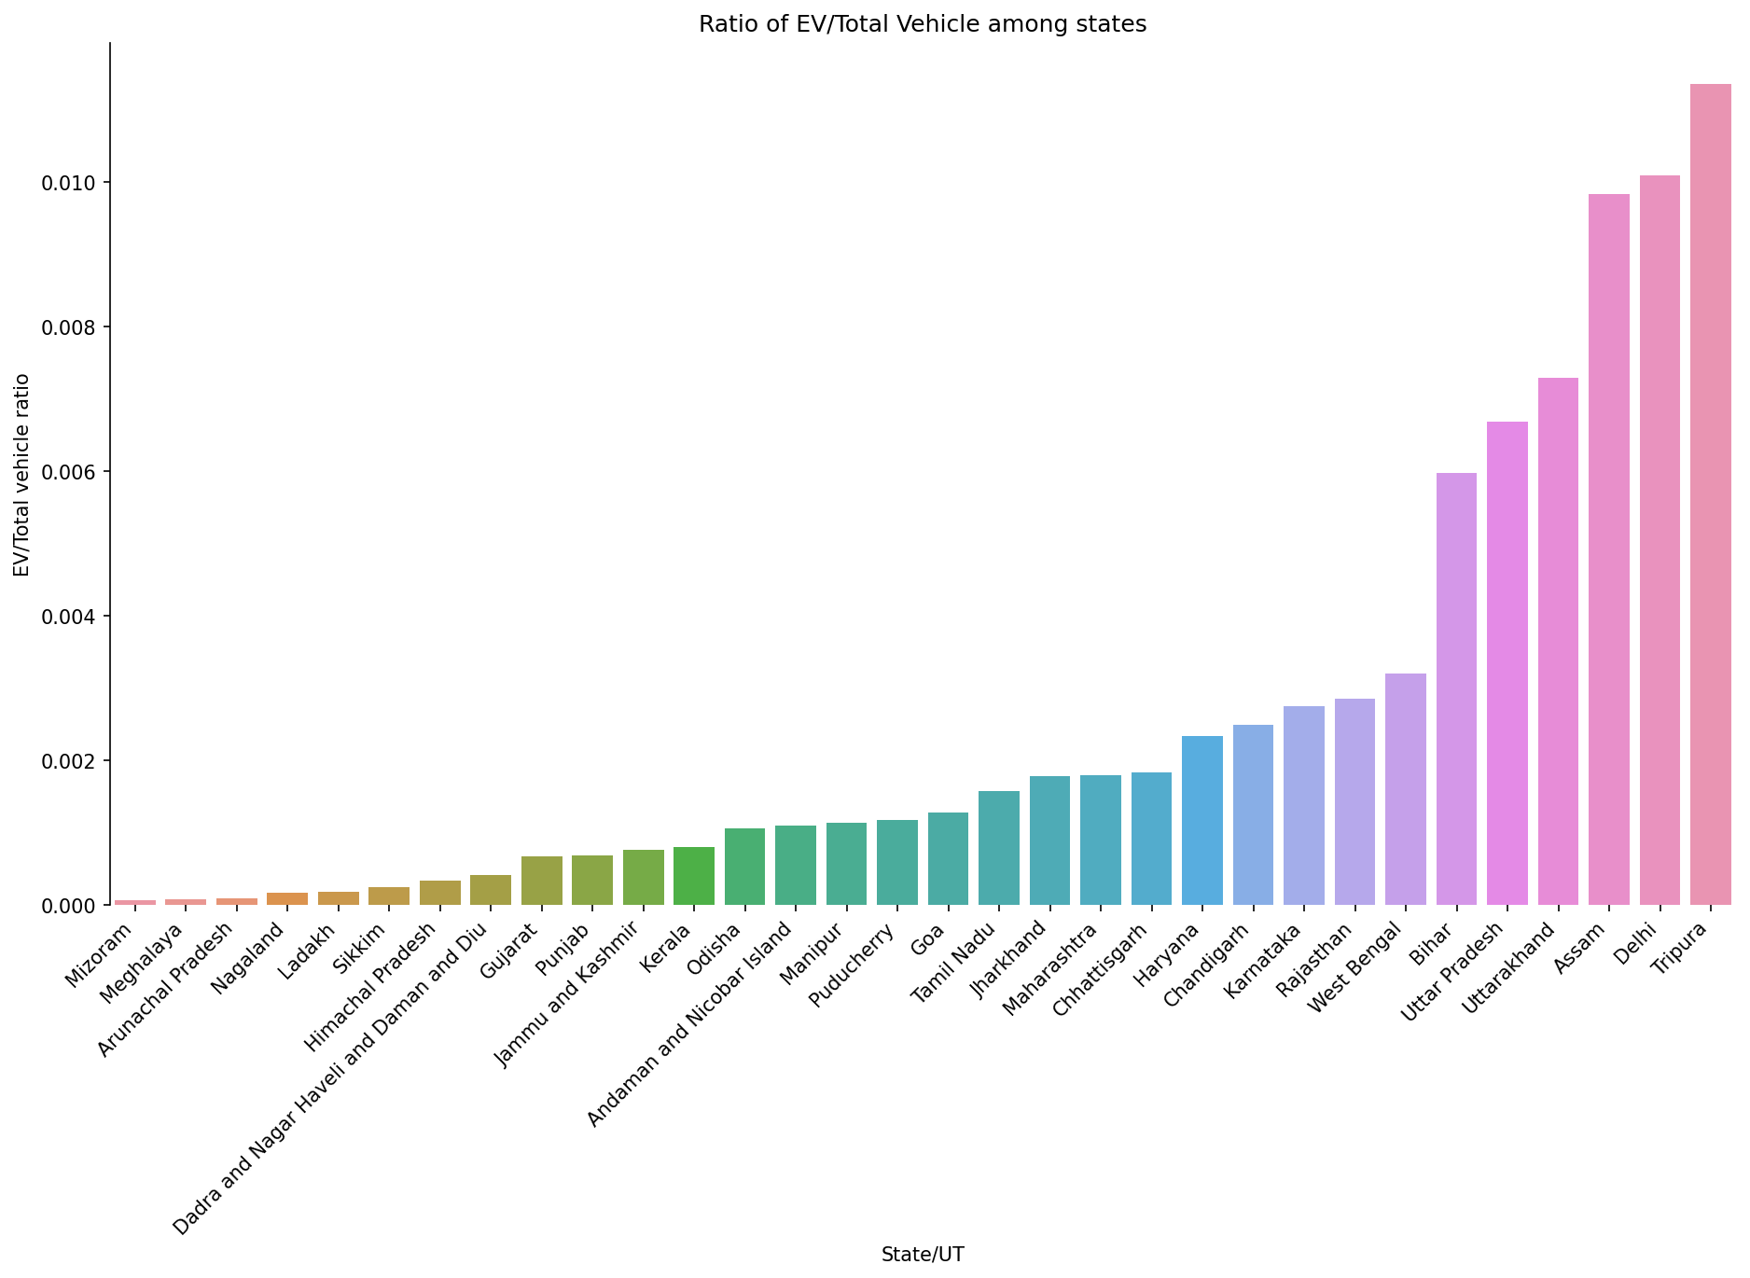

**EV charging stations across States/UT**

EV charging station availability tells about ease of recharging electric vehicle and that can impact the consumers to adopt electric vehicles at pace.

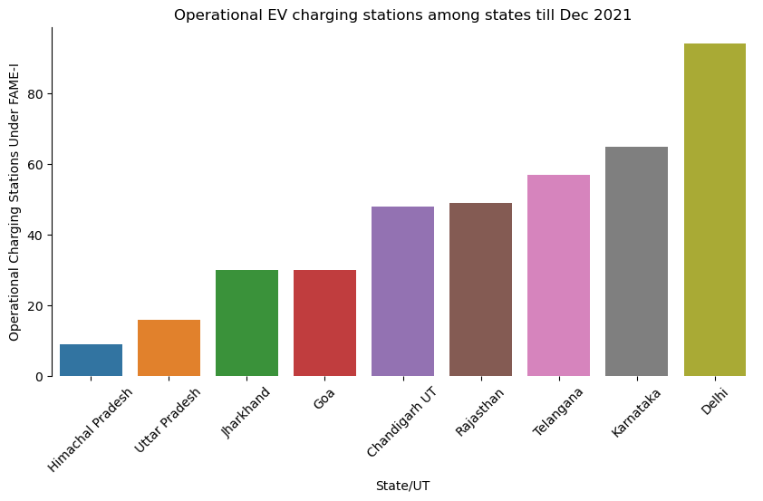

States like Delhi Karnataka Telangana Rajasthan and Chandigarh should be given more preference in policy decisions while roll out for EV’s.

**Projections of EV stations in cities**

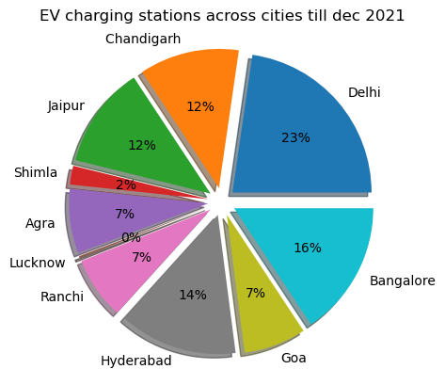

EV charging station are more in megacities so we should focus on megacities like Delhi, Bangalore, Hyderabad, and Chandigarh while deciding for policy related to EV cars.

**Sanctioned vs Deployed Charging stations**

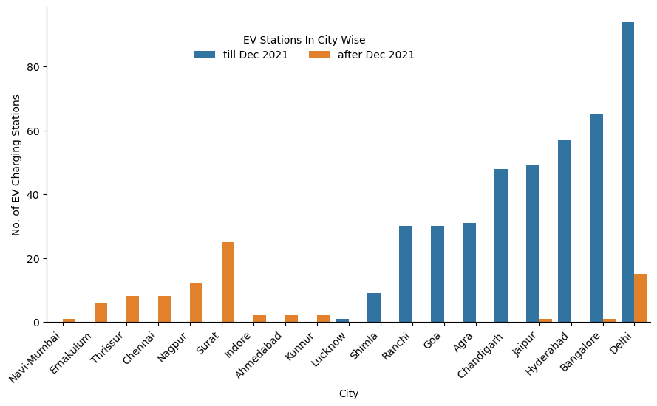

Blue bars show the EV stations deployed till Dec 2021 orange ones show the new deployed stations across new cities as well.

EV charging stations are deployed in new cities like Surat, Nagpur, Thrissur etc. as well new stations in previous cities but rate of deployment is low.

**New sanctioned stations at states**

The histogram below shows the number newly sanctioned EV charging stations across states like Maharashtra, Tamil Nadu, and Madhya Pradesh etc. have the largest number of deployed stations. These states have been lagging in EV charging stations but if the deployment happens then it would be invest in EV vehicles across these states.

But the matter of concern could be rate of deployment after being sanctioned as very few new stations have been deployed in states.

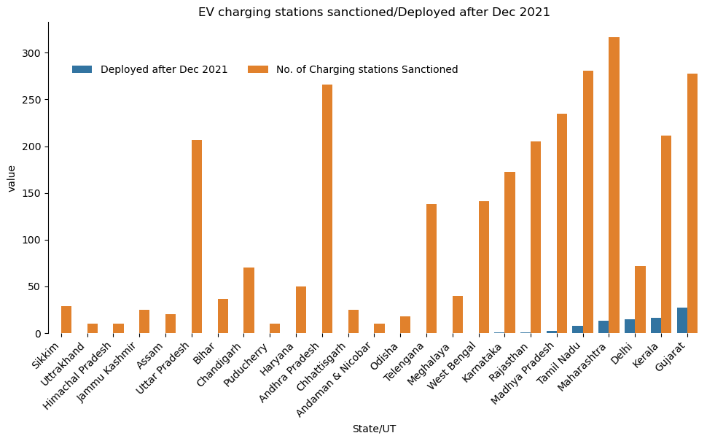

**EV charging station on highways and expressway**

Delhi-Kolkata, Mumbai-Delhi, Chennai-Bhubaneshwar highways are the leading in EV stations

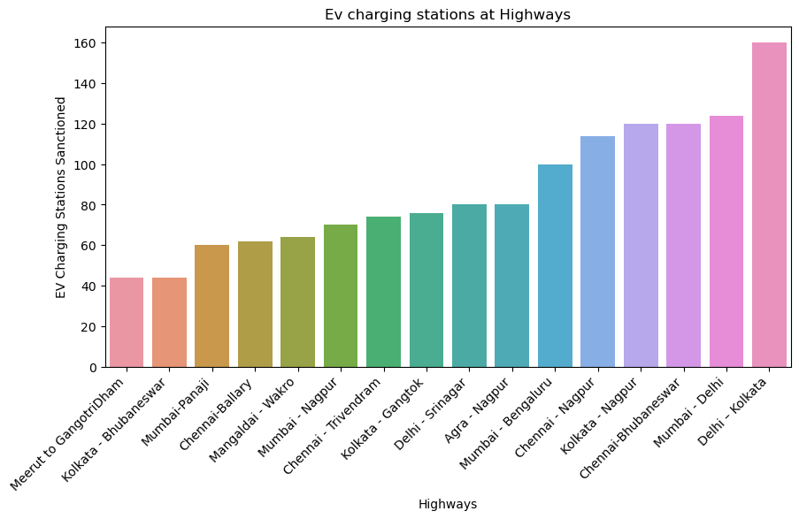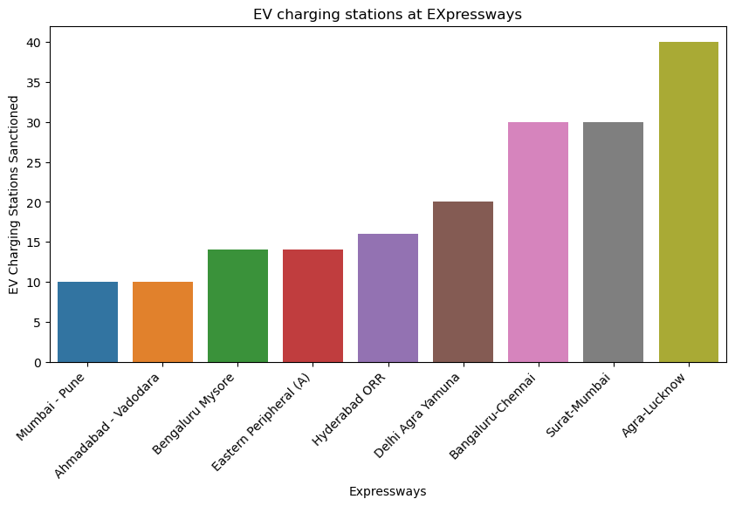

Agra-Lucknow, Surat-Mumbai, Bengaluru-Chennai are having high number of stations but the remaining expressways are also having average EV stations.

**K-means Clustering**

So to determine the regions having same characteristics are to be grouped based on states . to get a better insights into the regional variance the following variable have been taken into account

1. Total number of vehicles.
2. Charging station across states
3. Ratio of EV to the total vehicles

After doing the clustering to get optimal number of clusters plot of inertia vs cluster have been plotted to get elbow point.

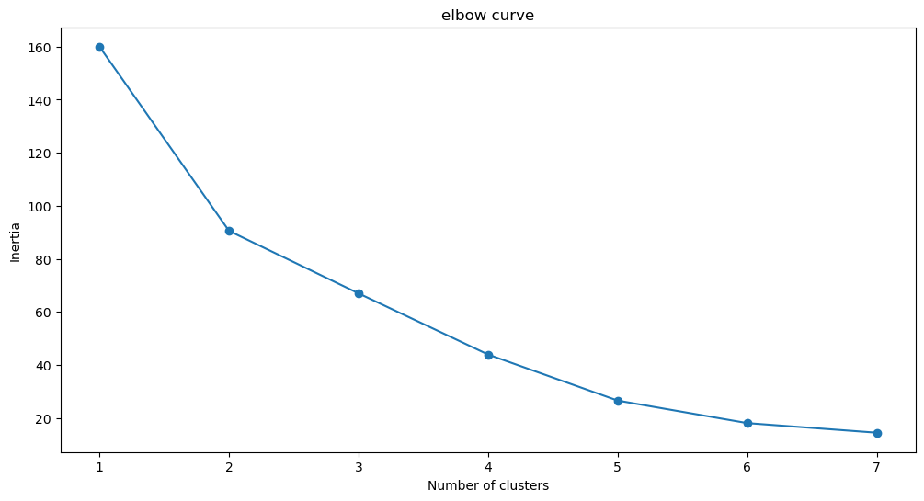

From the above curve optimal number of clusters can be selected as 5.

**Plot of clusters**

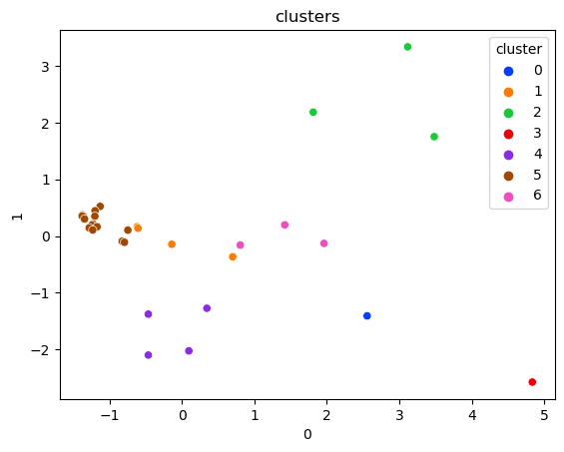

Here we can see clusters 5, cluster 4, cluster 2, cluster 6 are well separated when we take geographical segmentation as segmentation variable.

**Clusters of Regional Groups**

After clustering grouping based on regional variable have been shown

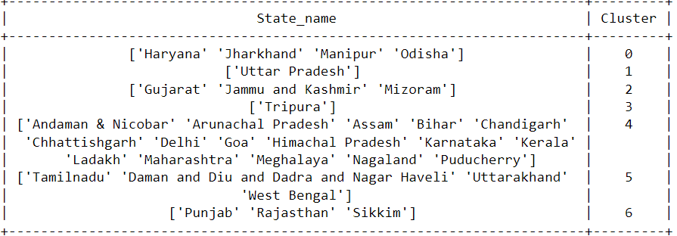

**Conclusion**

From this analysis we can easily conclude that based on Geographical segmentation variable we can divide whole states of India across 5 regions. Based on EDA we can select which group are beneficial as they tell us about regions with leading parameters such as no. of vehicles, no. charging stations, interest of energy sector companies etc.